|  |  |  |  |
| --- | --- | --- | --- |
| **SVKM's-IOT, Dhule**Shri Vile Parle Kelavani Mandal's  **INSTITUTE OF TECHNOLOGY**  **DHULE (M.S.)**  **DEPARMENT OF COMPUTER ENGINEERING** | | | |
| **Subject :** Java Programming Lab (Seminar-I) | | | Remark |
| **Name :**  Ansari Asharul Ameen Naeem Ahmad | | **Roll No. :** 63 |
| **Class:** SY. Comp. Engg. | **Batch : S4** | **Division: A** |
| **Expt. No. :**06 | **Date :** 14 /10/2024 | | Signature |
| **Title :**  Write Java Programs on Classes: String and Math. | | |
|  | | |
|  | | |

**Code:**

import java.util.Scanner;  
public class max  
{  
public static void main(String[] args)  
{  
String str1,str2;  
Scanner s = new Scanner(System.in);  
System.out.println("Enter Two Strings");  
str1=s.next();  
str2=s.next();  
  
System.out.println("Length of String str1= "+str1.length());  
System.out.println("Length of String str2= "+str2.length());  
System.out.println("String Upper Case Method= "+str1.toUpperCase());  
System.out.println("String Lower Case Method= "+str2.toLowerCase());  
System.out.println("String Char At Method= "+str1.charAt(2));  
  
System.out.println("String Equals Method");  
if(str1.equalsIgnoreCase(str2))  
{  
System.out.println("Strings Are Equals");  
}  
else  
{  
System.out.println("Strings Are Not Equals");  
}  
System.out.println("String Compare To Method= "+str1.compareTo(str2));  
  
}  
}

|  |  |
| --- | --- |
|  |  |

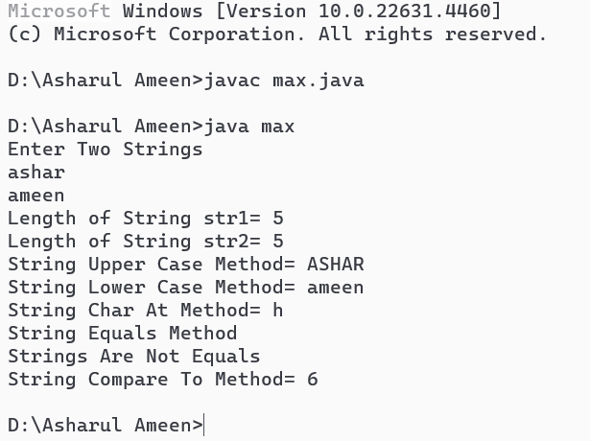

**CODE 2 :**

import java.util.Scanner;  
public class max2  
{  
public static void main(String[] args)  
{  
int x,y;  
float f;  
Scanner scanner = new Scanner(System.in);  
System.out.println("Enter Two Number");  
x=scanner.nextInt();  
y=scanner.nextInt();  
System.out.println("Enter Decimal Number");  
f=scanner.nextFloat();  
  
System.out.println("Square Root Methods= "+Math.sqrt(x));  
System.out.println("Sine Root Method= "+Math.sin(x));  
System.out.println("Power Method= "+Math.pow(x,y));  
System.out.println("Ceil Method= "+Math.ceil(f));  
System.out.println("Floor Method= "+Math.floor(f));  
System.out.println("Min Method= "+Math.min(x,y));  
System.out.println("Max Method= "+Math.max(x,y));  
System.out.println("Abs Method= "+Math.abs(f));  
}  
}

